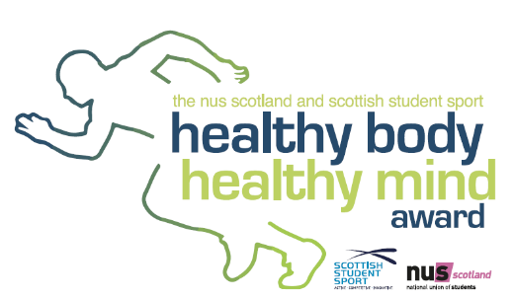
Healthy body, healthy mind event
Agenda
12 November 2018

12.30 – 13.00 | Registration
13.00 – 13.15 | Welcome and Introduction  Quick overview of the programme and introduction of the HBHM assessment panel
13.15 – 13.30 | How are you getting on with HBHM 2018/19?  Before starting the afternoon’s programme it will be useful to first reflect on where you currently are in the process and where you are heading.
13.30 – 14.30 | HBHM criteria for 2018/19  In this session we will have a closer look at the HBHM criteria for 2018/19 and hear from each panel member in the 4 strands of the award (Mental Health, Sports, Physical Activity and Smoking prevention/cessation).
14.30 – 14.45 Break
14.45 – 15.30 | Plans, ideas and challenges for HBHM 2018/19  Author Louisa May Alcott said “It takes two flints to make a fire” - so let’s talk to each other. In this session you’ll have a chance to chat to a few different institutions about your/their plans, ideas and challenges for this year’s awards.
15.30 – 15.50 | Q&A with HBHM assessment panel  Throughout the afternoon, you’ll have been given opportunities to post questions about all aspects of HBHM 2018/19. In this session the panel will consolidate and answer all the questions posted.
15.50 – 16.00 | Closing session

